C:\Users\Valerie\AppData\Local\Microsoft\Windows\Temporary Internet Files\Content.IE5\0SLD5WFN\MC900355103[1].wmf

**ZES Paw Print**

**PTA Newsletter - September 2013**

**Zebulon Elementary Gifted and Talented Magnet School**

*~ A School of Distinction ~*

**ZESPTA@yahoo.com**

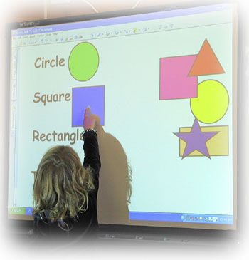



*This child is moving shapes from the right side of the screen to the correct word on the left side of the screen. If she moves the shape to the wrong word, it will jump back. This lets her know she made the wrong choice in a fun, non-threatening way.*

**PTA Get Acquainted Winners**

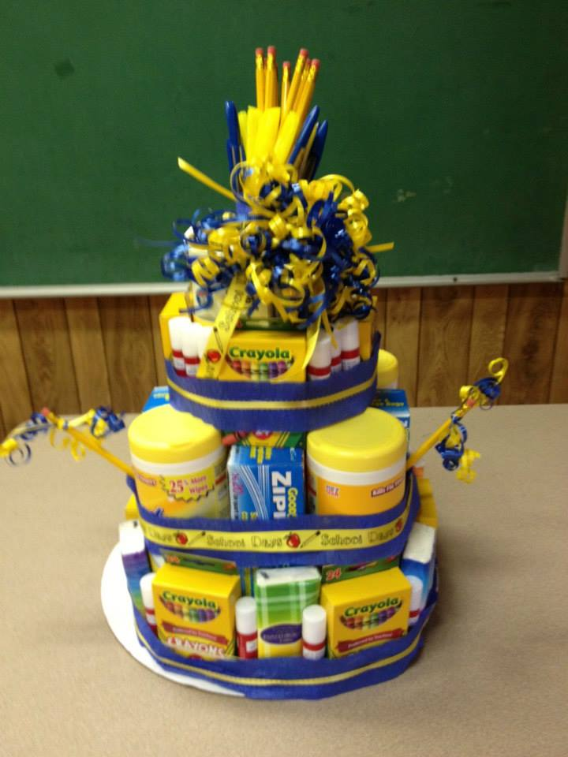Thanks parents for the great turnout on August 22nd for our annual Get Acquainted Night! Those present found their new classrooms & teachers, put money in lunch ac-counts, picked up carpool tags, and got transportation questions answered. The PTA Board & Membership Chair Amy Straughn recruited new PTA members & gave prizes to some who joined PTA that night.



Winners drawn from the **81** who joined were:

**Valerie Shelton**, **Jamie Foust**, **Esta Lampkin**,

**Loren Tant**, & **Jackie Chamblee** got pitcher sized tumblers from Barbie Carter Sales. **Jamie Foust** won a green tote from the same donor. **Nancy Spaulding** won designer fragrance & lotion donated by Belks*.*

If you joined but did not win, there are more drawings & prizes to come in our **Membership Rewards** program. If you haven’t joined yet – what are you waiting for?

***Mr. Peaden’s class won this supply cake from PTA by having the highest percentage of members join!***

**PTA gives $19,000 for SMART Boards**

Teachers Overwhelmed by Historic Gift

The ZES 2012-2013 PTA Board, led by 2-term President Traci Narron, is thrilled to report their last act - because of **YOUR** fundraising efforts over the last 2 years, **we were able to purchase and install 12 SMART Boards**!

Over the summer, each 3rd, 4th and 5th grade classroom was outfitted with these interactive, computer-linked whiteboards that make learning fun and engaging while preparing students for the 21st century workforce.

****The SMART Board purchase is a step toward achieving Principal Marion Evans’ goal to get more technology into our school: “Exposing our children to as much current technology as possible gives them the best chance at success.”

When PTA learned of this goal, they were determined to make it happen. “Just as we purchased books for each student last year in support of ZES’ literacy goals, we wanted to invest in technology in a way that would impact as many children as possible,” Ms.Narron said.

SMART Boards combine one of the most effective teaching strategies – hands-on learning - , with one of kids’ favorite things – computers. Special “markers” are used to “write” on the board and that info goes into the computer as if typing on a keyboard or clicking on a mouse. Things on the screen can be touched and moved around, opening up many new ways to teach, learn, and explore.

Fourth grade teacher Ms. K. Smith said, “Our PTA is beyond amazing for giving us these SMART Boards! I can’t wait to see the excite-ment of our kids when they get to interact with this technology.”

We can’t either

Mrs. Smith!

**Box Tops, Labels and Links**

Did you know you can help ZES PTA buy books, SMART Boards, & other great stuff by saving labels & box tops?

We collect Box Tops for Education, Labels for Education & Sunny D Book Spree labels. Go to their websites for a complete list of participating products. Ask friends, neighbors, family, and people at work to collect them and turn them in to earn cash & supplies for our school.

We also get money when you link your Food Lion Card or Target Card to our school. Stop by customer service and ask them to link your card to Zebulon Elementary, go online and do it yourself, or we will activate your Food Lion card for you if you send in the form below.

Look on copy paper, cereal boxes & all kinds of packages before you throw them out. Every single box top and label helps! Please check expiration dates and send them in ASAP so we can use them before they expire! THANKS!

 www.Btfe.com

Labels for education.gif



Name: _________________________________________

Phone Number: _________________________________

MVP#: ________________________________________

(make sure you have 12 digits)

**Target offers Funds**

If you use facebook, you can go to Give with Target, choose Zebulon Elementary, & vote for our school. We get $1 for every vote over 25 votes. You can vote once a week for a limited time. Please log in and tell all your facebook friends to vote for us!

**Important Dates**

Monday, **September 3rd** – PTA Board **5:30pm**

Friday, **September 6th** – Teacher Workday

Thurs., **September 18th** – Magnet Sheets go home

Thurs., **September 19th** – Thank You Thursday

Thurs., **September 19th** – ZES Open House &

General PTA Meeting **6:30pm**

Friday, **September 20 th** – Magnet Sheets Due

Thurs., **September 25th** – Interim Reports go home

Thurs., **September 26th** – McDonald’s Spirit Night

Friday, **September 27th** – Early Release **12:30pm**

Monday, **September 30 th** – First day of Electives

**Thanks to newsletter sponsor Wendell IGA**



**Hope to see you at the**

**PTA General Mee**

**ting on the 19sth**

**Welcome New Teachers**

**Your 2013-2014 PTA Board**

At our General PTA meeting in May 2013, you elected the following officers to serve this school year:

***Sarah Tant, President*** *Grandmother of**2nd grader*

***Traci Narron, Vice-President*** *Mom of 3rd & 5th graders*

***Gina Temple, Vice-President*** *Mom of 4th grader*

***Sherry Hayes, Secretary*** *Mom of 5th grader*

***Valerie Shelton, Treasurer***  *Mom of 2nd & 4th graders*

As your Board, we pay the bills, do the paperwork, plan & work out logistics. **We need active members like YOU** to help us with everything else from beautification to fund-raising to teacher appreciation! Please complete the form below and send in your $7 (ZES PTA) to join our team.

If you joined PTA but did NOT mark an area of interest, please take some time to look at the areas where we need help & let us know where YOU would like to be plugged in. If there is something you’d like to do that you do not see listed, contact us at [ZESPTA@yahoo.com](mailto:ZESPTA@yahoo.com) .

- - - - - - - - - - - - - - - - - - - - - - - - - - - - - - - - - - - - - - - - - - - - - - - - - - - - - - - - - - - - - - - - - - - - - - - - - - - - - - - - - - - - - -

Please Join **Zebulon Elementary PTA** Only $7per person **Parent involvement = Student Success!**

**Member Name** ______________________________________ **Student Name** _________________________________

**e-mail** _____________________________________________ **Teache**r ______________________ **Grade** __________

**Member Name** ______________________________________ **Student Name** _________________________________

**e-mail** _______________________________________________ **Teacher** _____________________ **Grade** ___________

Please mark your areas of interest, talent, & skill so we can get you plugged in to your child’s education right away!

|  |  |  |  |
| --- | --- | --- | --- |
| Spanish/English | Fall/Spring Festival | Hospitality (food) | Newsletter/Comm. |
| Book Fairs | Field Day | Box Tops, store links, etc. | School store/Spirit wear |
| Visual & Performing Arts | Fundraising | Landscape/beautification | Teacher appreciation |
| Connect with Community | Health/Safety | Membership | Volunteer Coordinator |
|  |  |  |  |