Teacher Pairs for FREE COOKIE DOUGH!
Pre K  Robinson- Brown  Mitchell-Flowers | Kindergarten  Best – Burke  Bryant – Boykin  Somers – Hinson  Morrisey – Owen | First Grade  Groh – Deaton  A.Johnson – Holden  G. Johnson – Cutner  Woodlief - Witt
2nd Grade  DeRoche – Loucks  Gwyn – Bissette  Martin – Parker  Wallace – Taylor | 3rd Grade  Chartrand – S. Wall  Gamble – Moore  Guitierrez – Allen  E. Smith – Evrard | 4th Grade  McCullough – Ahart  Peaden – Douna  K. Smith – Bunn
Unassigned Evans  Holley  Jarrett  Spain | 5th Grade  Fay – Hannah  Fullwood – L. Johnson  Tucker – Kiennemur  Zielinski - Parham | Wise Unassigned Saavadra  Linyear Spain  Pretty Watkins  Guidi Wesley  Suggs

3 WAYS to help ZES raise money! 1)Buy tickets to the NC State Fair (Oct. 17-27)
2) See Back for info on Fall Fundraiser & Spirit Night
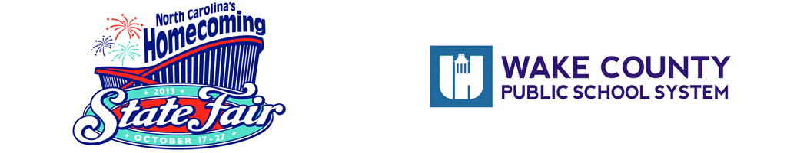
Each $7.00 adult advance ticket purchased = $2 for ZES
Every $3 children's advance ticket = $1 for ZES
Please tell your friends, family, & neighbors! The more tickets ZES supporters buy, the more money is returned to our school. Be sure to enter our school code 632 (it’s on the advance ticket online site):
Buy Tickets for WCPSS - 2013 NC State Fair Gate Admission
Don't wait!: Once the fair starts, ticket prices go up & no money comes to us.

Fall Fundraiser – NOW through October 7th
1 product (cookie dough), 1 price ($15) other items available online
at www.gaschoolstore.com School Code - 3286143

ZES Spirit Night at McDonald’s
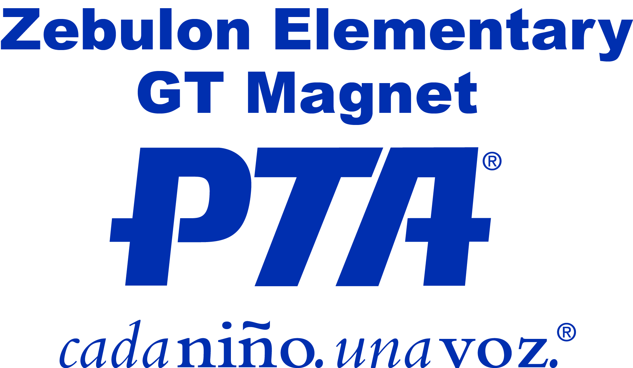
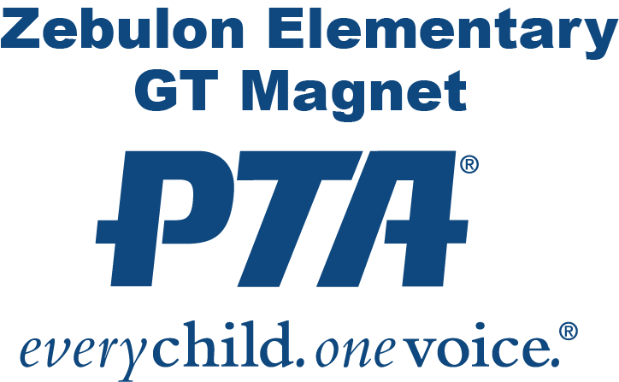
Thursday, September 26, 2013 5pm-8pm

