

**ZES Paw Print**

**PTA Newsletter - October 2013**

**Zebulon Elementary Gifted and Talented Magnet School**

*~ A School of Distinction & NC Reward School ~*

**ZESPTA@yahoo.com**

**[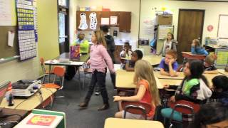](http://www.youtube.com/watch?v=k-Z_fmjRzgU&feature=em-share_video_user)**http://s.ytimg.com/yt/img/email/digest/email_header.png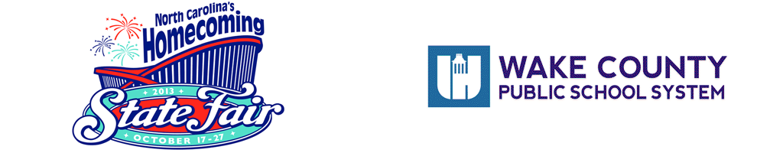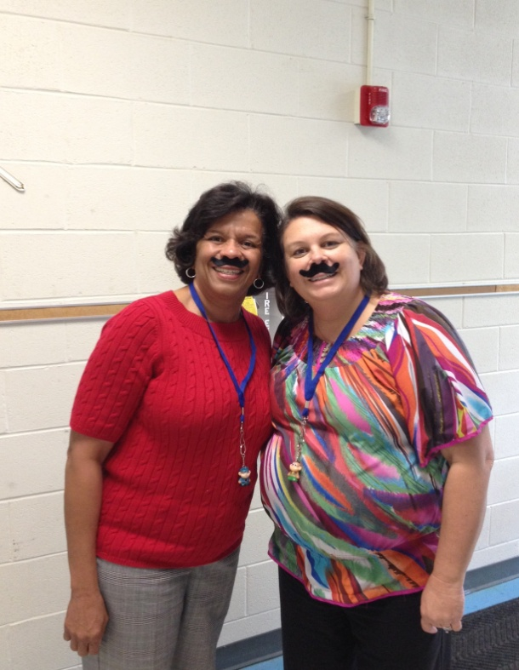

**Thank You!!!**

**We raised $509.97** thanks to everyone who came out to McDonald’s on September. 26th to support our school! Please express our deep gratitude to everybody you invited or brought with you. You ROCK!

|  |
| --- |
| [**Zebulon Elementary PTA brings new technology to classrooms**](http://www.youtube.com/watch?v=k-Z_fmjRzgU&feature=em-share_video_user) by [WakeCountySchools](http://www.youtube.com/user/WakeCountySchools?feature=em-share_video_user) |

Your hard work over the last 2 years has been noticed by the Communications Department at WCPSS! Here is the link to the You Tube video they made about us.

Thanks to Your hard work over the last two years, we are being featured by WCPSS on their You Tube site.

**Buy Fair Tickets & Earn Funds for ZES PTA**

**ZES on**

**1600 items available for purchase online** at [www.gaschoolstore.com](http://www.gaschoolstore.com) **school code 3286143**

**1 item** = **monkey** **on a lanyard**.

**2 items** = **add dance party**

**5 items** = **add** **another monkey & ice cream party**

**10 items** = **add another monkey** & **a pizza party**

**15 items** = **add entire monkey family** **and a movie**

Please remind your child of all safe selling rules, including never selling alone or to strangers. You can help your child think of friends, family, neighbors, & co-workers who might support our school and decide if a phone call or visit would be best.

Don’t forget about the online option - 1600 items available for purchase online at [www.gaschoolstore.com](http://www.gaschoolstore.com) . Register your child and use our **school code 3286143**.

On September 23, Mr. Cash visited ZES to kick off the fall fundraiser. **Our goal** is to raise **$6,000** to mount our SMART Board projectors on the ceiling. This will keep the cords & machine safely out of the way and get rid of the shadows on the Boards when we work.

Tubs or boxes of cookie dough are $15 each and will be sold from now until **October 7th**. Remember: :there are **1600 items available for purchase online** at [www.gaschoolstore.com](http://www.gaschoolstore.com) . Just register your child and use our **school code 3286143 .**

, just one item earns a cute little monkey on a lainyard. Two items brings a ticket to a dance party and five items adds another monkey and an ice cream party!

For those who sell 10 items there will be another monkey and a pizza party and for the super stars selling 15 items, they get the entire monkey family and a movie!

**Each $7.00 adult advance ticket purchased = $2 for ZES**

**Every $3 children's advance ticket = $1 for ZES**

If you or someone you know is planning to attend the NC State Fair October 17th-27th, please buy advance tickets at   
[Buy Tickets for WCPSS - 2013 NC State Fair Gate Admission](http://wakeacademy.us7.list-manage1.com/track/click?u=7d283bf553fdec95f3f710654&id=6885ada8ef&e=26217f06d2) Enter our school code **632** (it’s on the website)

Be sure to tell your friends, family, & neighbors! The more tickets ZES supporters buy, the more money we raise.

**Don't wait!:  Once the fair starts, prices go up &**

**no money comes to us.**

achievement program for Pre-K- 12th grade students. It gives students an opportunity to express themselves & get positive recognition for original works of art.

We encourage **all** **ZES** **students** to create original pieces of art that reflect this theme in the areas of dance, music, film, literature, photography, & visual art.

Each piece needs a Student Entry Form with a description of how their art relates to the theme for each piece of art they submit. A copy of the General Rules & Art Specific Rules can be found at <http://www.wakepta.org/reflections-program/>. All of our arts teachers will have copies as well.

Artists from the community will view ALL submissions and select the art that best represent this year’s theme to advance to the Wake County Reflections Contest. Winners there advance to state and national competition.

The **Deadline** to submit art for Reflections is Tuesday, **October 29th**. We can’t wait to see how you ***Dream, Believe, Inspire!***

***Dream, Believe, Inspire*** – that is the theme for this year’s Reflections art contest sponsored by National PTA. Reflections is an arts recognition and

**PTA Art Contest**

***Mrs. Evans & Mrs. Spain model some of the prizes students can earn in our fund-raiser. They’ll do anything for our kids!***

**Anything for our Students!**

Labels for education.gif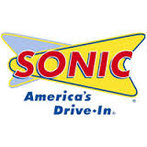

We have 175 members so far, but we need 227 to meet our goal of 20% growth for the 3rd year in a row,. Here are the Membership Rewards winners from our September 19thmeeting:

***Amy Keel & Elaine Hughes Mudcats Boxed Seats (4)***

***Jessica Guitierre, $10 gift certificate to Fargo’s***

***Hope McCullough & Keri Peevey $25 IGA Gift Card***

***Amanda McGrath Garden Flag & Stand, Michael Blake’s***

You can win the next drawing if you join! Please complete the form below and send in your $7. (Checks to ZES PTA) **We need active members like YOU** to keep doing great things. If you already joined but didn’t mark an area of interest, please let us know where YOU would like to be plugged in.

**ZES PTA 2013-2014 Membership Form**

**Annual Dues (Gastos Anuales) $7.00 per person** (National, State, Local) (Nacional, Estado, Local)

**Member’s Name (Nombre del miembro)** ___________________________________________ _________________________

**Member’s Employer (Nombre del employer)** _________________________________________ _ _______________________

**Address (Dirección)** _______________________________________________________________ ___ZIP__________________

**Telephone Number (Número de teléfono)** ______________________ **Email**_______________________ __ _ _____________

**Student** ___________________________________________ **Grade**  ___ **Teacher (Maestro(a))**__________________________

**Student** ___________________________________________ **Grade**  ___ **Teacher (Maestro(a))**__________________________

**Amount Enclosed (Cantidad Incluído)** $________________________________________ (Checks payable to ZES PTA)

Your involvementcan **IMPROVE your child’s Academic Performance by as much as 86%!!!!!** It can also **decrease** **disciplinary actions and behavior issues**. Thank you for joining ZES PTA! Help us be respectful of your time & energy by noting activities in your areas of interest. Please check all that apply.

|  |  |  |  |
| --- | --- | --- | --- |
| Hospitality (food) | Field day | Reflections (Fine Arts) | Box Tops & Labels |
| Webmaster | Grant Writing | Newsletter/Publicity | School Store/Spirit Wear |
| Volunteer Coordination | Health & Safety | Staff Appreciation | Grade level celebrations |
| Advocacy | Spanish/English | Book Fair | Literacy Programs |
| Fundraising | Membership | Landscape/Beautification | Visual + Performance Arts |

**Box Tops, Labels and Links**

www.Btfe.com

- - - - - - - - - - - - - - - - - - - - - - - - - - - - - - - - - - - - - - - - - - - - - - - - - - - - - - - - - - - - - - - - - - - - - - - - - - - - - - - - - - - - - -

We collect Box Tops for Education, Labels for Education & Sunny D Book Spree labels. Each website has a complete list of participating products. Please ask friends, neighbors, family, and co-workers to save them for you to earn cash & supplies for our school.

Food Lion & Target also donate to our school when you link ZES to your card. Ask customer service to link your card to Zebulon Elementary, go online and do it yourself, or send in the form above and we will do it for you!

Check copy paper, Kleenex, Cereal & all kinds of products before you throw them out. Every single box top, link & label helps! Please check expiration dates and send them in ASAP so we can use them before they expire! THANKS!

Monday, **October 7thth** – PTA Board Meeting

Monday, **October 14th** – Book Fair Opens

Tuesday, **October 15th** – Book FairFamily Nite **5-6:30pm**

Tuesday, **October 15th** – NC Stem Night **5:30 – 7:30 pm**

Thursday, **October 17th** – Last Day of Book Fair

Friday, **October 18th** – Early Release

Tuesday, **October 22nd** – Spirit day at SONIC, all day!

Friday, **October 25th –** Family School Partnership **9-10am**

Friday, **October 25th –** End of 1st Quarter

Monday, **October 28th –** Teacher Workday

Tuesday, **October 29th –** 2nd Quarter Electives Begin

Tuesday, **October 29th –** Reflections Art Entries Due

**Important Dates**

**PTA Membership Rewards**

breakfast, lunch, or dinner. Better yet, get all 3! ZES PTA will receive a percentage of all sales at the Zebulon location. Please encourage family, friends & coworkers to help us out by eating at Sonic on October 22nd.

**ZES Spirit All Day**

If you are in Zebulon on Tuesday, October 22nd, please stop by Sonic for

Name: _________________________________________

Phone Number: _________________________________

MVP#: ________________________________________

(make sure you have 12 digits)